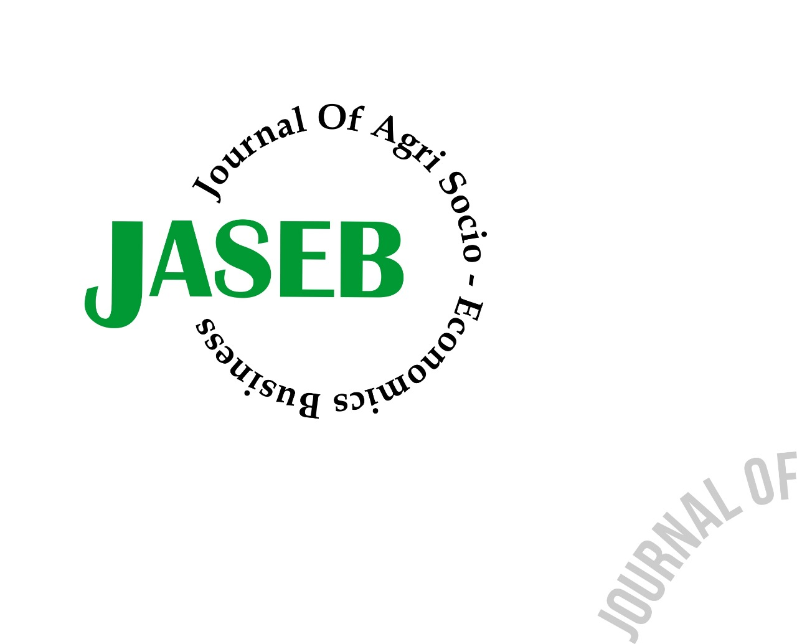 **Journal of Agri Socio-Economics and Business (JASEB)** Available online at : <https://ejournal.unib.ac.id/index.php/jaseb/index>

DOI: 10.31186/jaseb.2.1.23-30

THE ECONOMIC DIMENSION SUSTAINABILITY ANALYSIS OF THE *NA-OOGST* TOBACCCO BUSINESS IN JEMBER

##### Nila Afila1);Muksin2); Ujang Suryadi3)

1)Study Program of Agribusiness Magister, Politeknik Negeri Jember

2)Major of Agribusiness Management, Politeknik Negeri Jember

Email: 1) [nila.nafila2412@gmail.com](mailto:nila.nafila2412@gmail.com); 2) [muksin.alyasini@gmail.com](mailto:muksin.alyasini@gmail.com)

**How to Cite :**

Afila, N., Muksin. 2020. Analysis Of The Economic Dimension Sustainability of the *­Na-Oogst* Tobacco In Jember. *Journal of Agri Socio-Economics and Business*. 1 (1): 23-30. DOI:https://doi.org/10.31186/jaseb.2.1.23-30

|  |  |
| --- | --- |
| **ARTICLE HISTORY**  Received [14-05-2020]  Revised [20-05-2020]  Accepted [27-05-2020] | ABSTRACT Na-oogst tobacco commodity is an export commodity that has a role in increasing national income through excise tax. Many factors can influence the decision of farmers to conduct tobacco cultivation in the midst of enormous pressure on tobacco products. This study aims to analyze the economic dimension sustainability of the na-oogst tobacco business in Jember. The metodology used is Multi Dimensional Scaling (MDS) to analyze sustainability by using 10 atributs. The results of the analysis of the economic dimension show that the na-oogst tobacco business in Jember is categorized as "quite sustainable" with a value of 51,17. The factor that greatly affect the sustainability of the economic dimension and need to be considered is Price Stability with an attribute effect value of 6.77.    **.** |
| **KEYWORDS**  Sustainability,  Na-oogst tobacco,  MDS, |
| **This is an open access article under the** [CC–BY-SA](http://creativecommons.org/licenses/by-sa/4.0/) **license** |

INTRODUCTION

The agricultural sector is a sector that plays an important role in improving the Indonesian economy. The agricultural sector contributes significantly to the growth of the Indonesian economy in terms of its distribution to the National Gross Domestic Product (GDP). The contribution of the agricultural sector to the National GDP was 13,41% and have the third ranks after the industrial and other sectors. (BPS, 2019)

One of the sub-sectors in the agricultural sector that has an important role in increasing state revenues through taxes is the plantation sub-sector. Most of whose commodities are export commodities, one of which is *na-oogst* tobacco plants.

Jember is one of the largest *na-oogst* tobacco producing areas in East Java. From ​​13,392 hectares of tobacco plantation area in Jember. 2,302 hectares are of *na-oogst* tobacco plantations with a total production of 5,064, 40 tons in 2018. (BPS, 2019)

Table 1. Percent Distribotion of Gross Regional Domestic Product in the Agriculture Sector of Jember 2014-2018

|  |  |  |  |  |  |
| --- | --- | --- | --- | --- | --- |
| Agricultural Sector | Agricultural Sector Contribution (%) | | | | |
| 2014 | 2015 | 2016 | 2017 | 2018 |
| Crops | 26,52 | 25,72 | 24,98 | 23,50 | 23,55 |
| Horticultural Plants | 8,83 | 8,90 | 9,49 | 9,71 | 10,04 |
| Plantation Crops | 36,50 | 37,17 | 37,13 | 36,88 | 35, 36 |
| Animal Husbandry | 17,05 | 17,07 | 17,25 | 18,09 | 18,80 |
| Fishery | 6,94 | 7,06 | 7,08 | 7,63 | 8,02 |
| Forestry and Logging | 3,10 | 3,00 | 3,00 | 3,09 | 3,17 |
| Agricultural and Hunting Services | 1,07 | 1,09 | 1,08 | 1,09 | 1,06 |

Source : BPS Jember, (2018) and (2019)

Based on table 1. plantation crops are the sub sector that has the highest contribution to increasing the Gross Regional Domestic Product (GRDP) of Jember. The area of tobacco plants has increased by 5% from the previous year. However *na-oogst* tobacco production in Jember experienced a very drastic decline in 2018. Total *na-oogst* tobacco production decreased by 84,46% from the previous year. (BPS, 2019)

The decline in tobacco plant production can be caused by various factors, including extreme weather that occurred in 2019 which caused tobacco plants, especially *na-oogst* types of tobacco do not have enough water in their cultivation process. In addition, the amount of capital needed in the process of the tobacco cultivation make some farmers do not have the desire to grow commodity types besuki *na-oogst* and switch to other commodities.

Another factor is tobacco prices. The price of tobacco that is not guaranteed and often experiences a very drastic decline. This condition can also threaten the sustainability of the *na-oogst* tobacco business in Jember. Based on this discussion, it can be concluded that the factors which cause unsustainability of *na-oogst* tobacco business in Jember are mostly related to the economic dimension. Therefore, it is necessary to study the sustainability status of the *na-oogst* tobacco business in Jember focusing on economic dimension. So that it can be examinated determinant factors of business sustainability.

RESEARCH METHODS

## Method of Collecting Data

This research uses primary and secondary data types. Primary data were obtained from interviews with experts, the head of Farmers Group (Poktan), the head of Farmers Group Association (Gapoktan), the management of Poktan and Gapoktan, members of Poktan and Gapoktan, as well as other parties related to the research.

Secondary data is data obtained from related agencies to complete primary data. Secondary data is used as supporting data in the analysis of the sustainability of the *na-oogst* tobacco business in Jember.

The sampling technique in this study is to use a purposive sampling method, which is the determination of the sample based on several considerations or certain criteria set in accordance with the objectives of the study. The sample used in this study was 5 expert respondents who had the capability to conduct an assessment of the sustainability of tobacco commodities.

Respondents in this study were the Head of the Tobacco Plantation Plant Division of Jember Horticultural Food And Plantation Office, Chairperson of the Indonesia Tobacco Farmers Association (APTI) of Jember, Chair of Jember Association of Farmers Group (Gapoktan), Extension and Farmers.

## Data Analysis Method

Data processing and analysis in research carried out using Multi Dimensional Scaling (MDS). The analysis of the sustainability of the *na-oogst* tobacco commodity using MDS aims to find out whether the *na-oogst* tobacco commodity in Jember has future sustainability seen from the smallest line, namely through Poktan and Gapoktan.

MDS in this study is used as a tool to determine the status of the sustainabilty of the economic dimension of the *na-oogst* tobacco business in Jember by looking at the Gapoktan Cahaya Muda and Poktan incorporated in it.

The attributes used in this analysis are : 1) farmers income, 2) land ownership status, 3) marketing access, 4) market reach, 5) government assistance, 6) price stability, 7) productivity of agricultural products, 8) feasibility of farming, 9) the selling price of tobacco to Break Even Point (BEP), and 10) the bargaining position of farmers.

Analysis of the sustainability of the *na-oogst* tobacco business in Jember uses the RSITM Software (*Rapid Sustainability Index)* developed (Budiharsono dan Firmansyah 2016) for an assessment of the sustainability function in general. RSITM is modified program from the RAPFISH (*Rapid Assessment Techniques for Fisheries*). This study more specifically uses the development of RAPFISH, namely RAP-TOBACCO (*Rapid Assessment Techniques for Tobacco*)*.*

The sustainability index value used has an interval of between 0% - 100% using a scale developed by the University of Columbia, Canada

Table 2. Sustainability Status Category

|  |  |
| --- | --- |
| **Index Value** | **Category** |
| 0,00 – 25,00 | Not Sustainable |
| 25,00 – 50,00 | Less Sustainable |
| 50,00 – 75,00 | Quite Sustainable |
| 75,00 – 100,00 | Very Sustainable |

Source : Fauzi dan Anna,2015

RESULTS AND DISCUSSION

Based on the analysis that has been done, the sustainability of the *na-oogst* tobacco business in Jember seen from the economic dimension can be seen in figure 1.

**Na-oogst Sustainability**

Figure 1.

Sustainability Status of the Economic Dimension

Viewed from the economic dimension, the *na-oogst* tobacco business in Jember is categorized quite sustainable with a value of 51,17. The value indicated the sustainability status of the *na-oogst* tobacco commodity is in the position of the ordination scale between 50,00 – 75,00. It means that the *na-oogst* tobacco business in Jember will sustain because it has a quite good economic impact which will influence the farmer’s decision to continue the *na-oogst* tobacco business.

The effect of each attribute on the economic dimension on the sustainability of *na-oogst* tobacco business in Jember can be seen in Figure 2.

Figure 2.

Laverage of Attribute

Based on figure 2. the most important factor that influences the economic dimension and really needs to be considered is price stability with the value of the attribute effect of 6,677. Price stability has the highest sustainability scale which means that this attribute is a very important attribute in the economic dimension to support the farmer’s decision to continue the *na-oogst* tobacco business..

The most important factor that effect the economic dimension and really need to be considered starting from the most important attributes to the least influential attributes in the sustainability of the *na-oogst* tobacco business in Jember are :

1. Price stability with the value of the attribute influence of 6,77. It means that price stability is the first driving factor in supporting the sustainability of the *na-oogst* tobacco in Jember. The farmer’s in Jember will prefer to cultivate crops that have stable price
2. Government assistance with an attribute influence value of 6,60 is the second driving factor in supporting the sustainability of the *na-oogst* tobacco in Jember. In Jember, the government has provides less assistance to *na-oogst* tobacco farmers than food crop and horticultural farmers.
3. Market reach with the effect value of the attribute of 5,71 is the third driving factor in supporting the sustainability of the *na-oogst* tobacco in Jember. *Na-oogst* tobacco is an export commodity that makes farmers interested in continuing to do business in this field.
4. Marketing access with the value of the attribute effect value of 5,31. *Na-oogst* tobacco farmers in Jember do not have independent access to marketing, they are still dependent on tobacco companies. This condition make farmers do not have a high bergaining value.
5. Land ownership status with the attribute effect value of 4,06. The status of *na-oogst* tobacco farmers land ownership in Jember is “their own”. The farmers with their owh agricultural land are farmers who have the potential to pay attention to sustainability dimension.
6. Farmer’s bergaining position with the attribut effect value of 2,97. The farmers must pay attention to the bergaining value of the commodity that is being cultivated.
7. Farmer’s income with the attribute value of 2,22. Farmers prefer to cultivating the *na-oogst* tobacco because the *na-oogst* tobacco prices are expensive and affect their income.
8. The selling price of tobacco with the effect value of attribute is 1,25. The farmer’s in Jember prefer to cultivate the *na-oogst* tobacco because the selling price of the *na-oogst* tobacco are expensive.
9. Feasibility of farming with the attribute value of 1,09. Tobacco farmers who have more than 1 hectare of agricultural land in Jember have considered conducting *na-oogst* tobacco cultivation.
10. Productivity of agricultural products with the attribute value of 0,52. Farmers will prefer to cultivating plants with high productivity.

CONCLUSIONS AND POLICY IMPLICATIONS

## Conclusions

Tobacco commodity has a big role in increasing Indonesia’s state revenue through sales tax and tobacco export tax. However, behind the big role of tobacco commodities, there is also considerable pressure that could threaten the existence and sustainability of the tobacco business, especially the *na-oogst* tobacco business in Jember. Therefore, an analysis of the sustainability of the *ba-oogst* tobacco business in Jember is deemed necesarry.

Based on the results of the analysis using Multi Dimensoinal Scaling (MDS) it can bee seen that price stability is very influential on the interest of farmers in conducting *na-oogst* tobacco cultivation (*na-oogst* tobacco farmers in Antirogo village). During this time, the price of mass tobacco has not been stable, this can be seen from the drop in tobacco prices in 2019, where tobacco which in general can be sold at a price of Rp. 8.000 per kg by farmers can only be sold at a maximum price of Rp. 4.000 per kg (head of APTI Jember). This condition makes farmers reluctant to plant tobacco in the next growing season for fear of experiencing losses. The creation of a stable price requires a synergy between the role of government through government institutions and the role of the private sector through related private institutions in Jember.

## Policy Implication

This research is expected to provide various benefits for the government of Indonesia. The result of this study can be used as a work program of local governments in order to maintain *na-oogst*  tobacco commodities and develop business, and can be used as a reference for the improvement and development of na-oogst tobacco commodities by the plantation division of the Horticultural Food and Plantation Office of Jember Regency.

REFERENCES

Badan Pusat Statistik Indonesia. 2018. *Produk Domestik Bruto 2014 – 2018*. Jakarta, BPS Indonesia.

Badan Pusat Statistik Kabupaten Jember. 2019. *Kabupaten Jember dalam Angka 2019*. Jember, BPS Kabupaten Jember.

Direktorat Jenderal Perkebunan. 2018. *Statistik Perkebunan Indonesia 2016 – 2018*. Sekretariat Direktorat Jenderal Perkebunan, Jakarta

Faridz, R., Ariffin., Soemarno., & Pramoedyo, H. (2018). Indeks dan Status Keberlanjutan Ketersediaan Tembakau Madura. *Jurnal Agriekonomika, 7*(2). 197-209.

Fauzi A, Anna S. 2002. *Evaluasi status keberlanjutan pembangunan perikanan. aplikasi pendekatan rapfish (studi kasus: Perairan Pesisir DKI Jakarta)*. Jurnal Pesisir dan Lautan. Bogor. Institut Pertanian Bogor. 4(3):14 – 21.

Fauzi A, Anna S. 2005. *Pemodelan Sumberdaya Perikanan dan Kelautan*. Gramedia Pustaka Utama, Jakarta

Firmansyah, Irman. 2016. *Model Pengendalian Konversi Lahan Sawah Di Dalam Das Citarum*. Institut Pertanian Bogor, Disertasi

Mardikanto T. 1993. *Penyuluhan Pembangunan Pertanian*. Surakarta, Sebelas Maret University Press

Marimin. 2004. Teknik dan Aplikasi Pengambilan Keputusan Kriteria Majemuk. Jakarta, Grasindo.

Menteri Kesehatan Republik Indonesia. 2018. *Peraturan Menteri Kesehatan Republik Indonesia Nomor 56 Tahun 2017*. Jakarta, Kemenkes

Menteri Pertanian Republik Indonesia. 2007. *Peraturan Menteri Pertanian Nomor: 27/Kpts/OT.160/4/2007*. Jakarta, Kementan.

Menteri Pertanian Republik Indonesia. 2013. *Peraturan Menteri Pertanian Nomor 82/Permentan/OT.140/8/2013*. Jakarta, Kementan.

Menteri Pertanian Republik Indonesia. 2016. *Peraturan Menteri Pertanian Republik Indonesia Nomor 67/Permentan/SM.050/12/2016 tentang Pembinaan Kelmbagaan Petani*. Jakarta, Kementan.

Muktianto, R. T., & Diartho, H. C. 2018. Komoditas Tembakau Besuki Na-Oogst dalam Perspektif Pembangunan Berkelanjutan di Kabupaten Jember.*Caraka Tani: Journal of Sustainable Agriculture*. 33(2),115-125.

Pagoray, H., Ghitarina., Asfie Maidie., Deni Udayana dan Ita Zuraida.2014.*Pemanfaatan Lahan Bekas Penambangan Batubara Untuk UsahaBudidayaIkan Yang Berkelanjutan*. Jurnal Dinamika Pertanian Volume XXIX Nomor (2) : 191 -198

Radar Jember. 2019. *Harga Tembakau Anjlok, Petani Merugi*. PT. Jember Intermedia Digital, Jember [diakses pada tanggal 12 Februari2020]

Ruhimat, Idin Saepudin. 2015. *Status Keberlanjutan Usahatani AgroforestryPada Lahan Masyarakat: Studi Kasus Di Kecamatan Rancah, Kabupaten Ciamis, Provinsi Jawa Barat*. Jurnal Penelitian Sosial Dan Ekonomi Kehutanan Vol. 12 No. 2

Undang-Undang Republik Indonesia Nomor 19 Tahun 2013 tentang Perlindungan dan Pemberdayaan Petani.

Widiatmaka., Khursatul M., dan Santun R.P. S. 2015. *Appraisal Keberlanjutan Multidimensi Penggunaan Lahan Untuk Sawah Di Karawang - Jawa Barat*. Jurnal Kawistara, Vol. 5, No. 2, Agustus 2015: 113-131